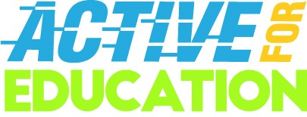
ACTIVE FOR EDUCATION (AFE)
AFE Activity Idea Sheet

Décor/Ambience
- Host an event at a climbing gym, track or other activity space. Bring literacy/education into the space/your décor.
  - A climbing wall that includes Room to Read milestones or facts at each hand and foot hold.
  - A set of hurdles (this should not obstruct free movement in the space) that include obstacles that the students Room to Read and its donors serve are overcoming through our work together.
  - A pathway toward the event space which includes milestone markers (mimicking distance markers in races)
Climbing Wall Inspiration Images
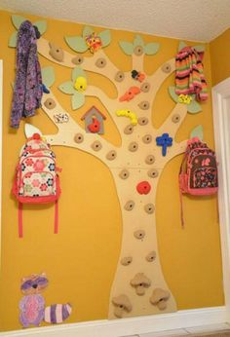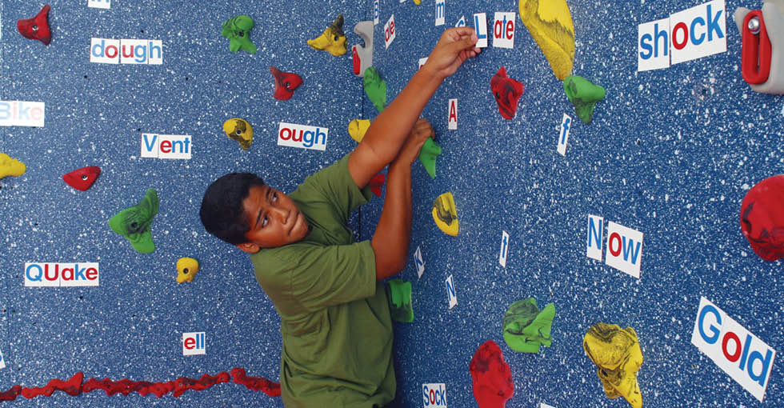
A tree (or non-tree, but the growth metaphor is a nice one) climbing wall that includes either hurdles children overcome (with Room to Read’s support) to achieve literacy/equality in education, upcoming Room to Read milestones, or program components needed to reach our goals around systemic change at each hand/foothold.

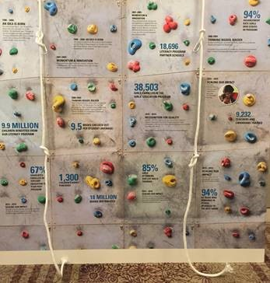

- Make “teams” (by table if applicable) and provide guests with a way to identify that team. This could be achieved by selecting a different color table cloth for each table, identifying each table with a different sports team or athlete’s name, etc.

- Integrate songs associated with physical challenges into the event soundtrack (e.g. “We are the Champions” when the total amount is revealed at the end of the night or “Eye of the Tiger” as walk-on music for a keynote speaker.)

Activities
- Make each table a “team” within a donation pledge system, and make mention of the team that has raised the most throughout the night (inspires competition, teamwork).
- Incorporate a silent or live auction. Look to solicit auction packages that focus on or integrate physical activity.

Speakers / Messaging
- Some possible event messaging for speeches:

  - “We are so grateful that you are with us in the race toward global literacy.”
  - “We are making great strides in our active pursuit gender equality in education.”
  - “We are ready to take on this challenge.”
  - “We are in a race against time and these children need us to step up.”
  - Goals: “Room to Read has always had BIG BOLD goals; we continue to set our goals even higher to reach more children.”
  - Strength: “Our board, our administration, our team, our staff and our volunteer chapters are strong and getting stronger in our pursuit of literate communities.”
  - Endurance: “We have endured failures and successes throughout our history. We continue to improve on these trials and tribulations.”
  - Balance: “We find balance between our two defined greatest needs: fundamental literacy skills for primary school students and secondary school education for girls.”
  - Races (sprints vs. marathons): “Sometimes we need to sprint and you are there for us. For example, you supported us when we shared the immediate need to reconstruct after Nepal's 2015 earthquakes. But ultimately, our greatest need is a marathon. We’re in it for the long haul until all children have access to a quality education.”
  - The Finish Line: “Help us reach the finish line! Our sights are set on finishing strong!”
  - Gold Medal: Cite awards given to Room to Read, to our book publishing, to individuals/corporate sponsors
  - Competitive: “We always look within ourselves and consult hard data to improve our processes and productivity, and to ensure we are always meeting the needs of the communities we serve.”
  - Investment in "Active/Exercise" Plan: “Tonight you’re investing in the ‘health’ of education in Africa and Asia. With your support, we have a fighting chance to win!”

